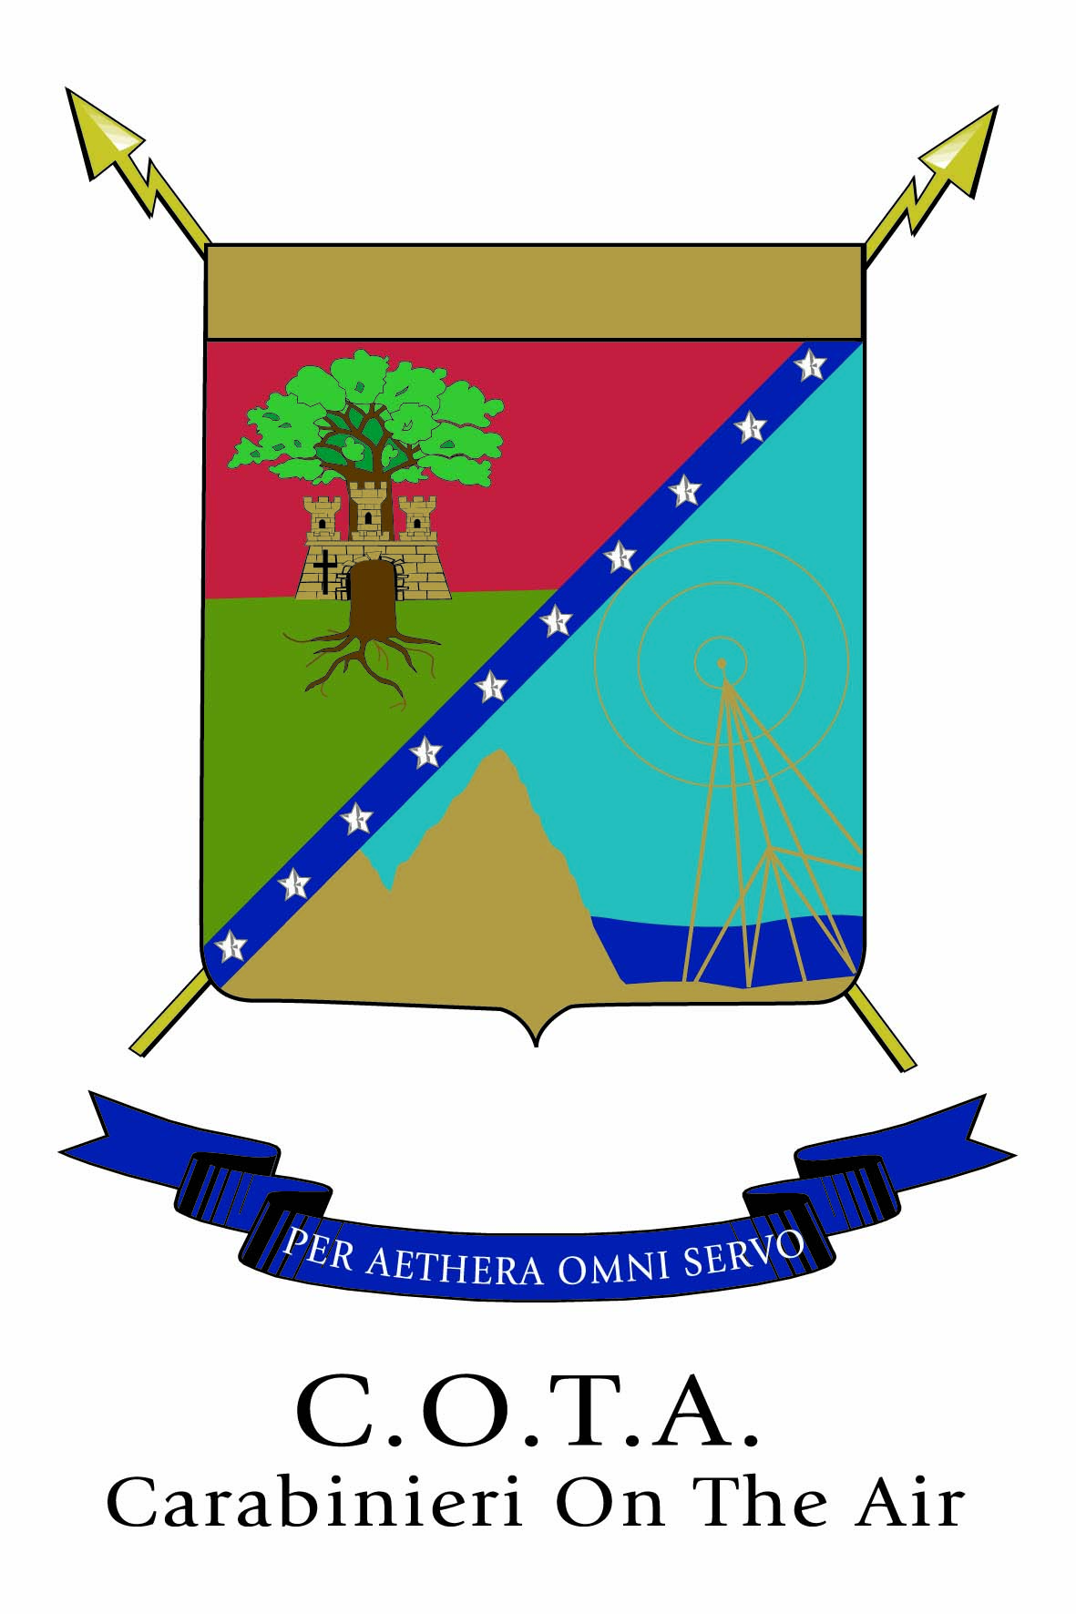
5th COTA AWARD 2009
(CARABINIERI ON THE AIR)
195° anniversary of Carabinieri Force foundation

0700 UTC, May 20 through 1900 UTC, 5 June , 2009

Objective: for amateurs and SWL around the world to contact COTA members amateurs in as many time as possible.

Bands : 3,5 MHz (80 mt.), 7 MHz (40 mt.), 14 MHz (20 mt.)
Mode: SSB, CW, PSK31, RTTY.

Contacts allowed: only one contact per day is allowed for the same band/mode/member . As many contact as possible per day are allowed with different band/mode/member.

COTA HAM members:

IK0AUO Walther
IK0QBI Enrico
IK0QOF Giancarlo
IS0YHV Antonio
IW0DGJ Antonio
IW0GSB Stefano
IW0EYT Massimiliano
IZ0IWL Gabriele
IZ0KNA Enzo
I1ULJ Salvatore
IK1MOP Vittorio
IW1DQS Davide
IK2SOB Fabio
IW2GRA Angelo
IW2NLJ Michele
IZ2ABM Giovanni
IZ2DJN Marco
IZ2KSC Giovanni
IZ2IPF Mauro
IZ2LNA Filippo
IK3ORD Maurizio
IV3FBH Tiziano
IV3PCF Giorgio
IV3TYS Dario
I4GVX Giovanni
IZ5IJY Sandro
IK6BAK Eliseo
IK6DUN Feliciano
IK6ZJE Domenico
IK6ZNK Francesco
IW6MNT Domenico
IZ6CRK Raffaele
IZ6FUQ Stefano
IZ6FYI Giuseppe
IW7EBB Gianluca
IW7EFJ Marco
IK8JAK Angelo
IK8XVQ Michele
IW8PQ Nino
IZ8BGA Massimo
IZ8CCX Agostino
IZ8DAF Sabino
IZ8FMU Massimo
IZ8GNF Francesco
IZ8LGW Pasquale
IT9ASX Gianni
IT9ECQ Enzo
IT9KKE Carlo
IT9ZJE Salvatore

For the official list of C.O.T.A amateurs member see at http://www.cota.cc

II0CC special call station will be active.

Points:
Contacts between amateurs and C.O.T.A. member in SSB mode count one (1) point
Contacts between amateurs and C.O.T.A. member in CW, RTTY and PSK31 mode count three (3) points
Contacts between amateurs and special station II0CC/zone any mode count five (5) points
Contacts between amateurs and special station II0CC any mode count height (8) points
Contacts between amateurs and “Jolly” station any mode count three (3) points

Number exchange : RS-T report plus progressive number (i.e. 59-001)
Call: SSB, RTTY and PSK31 “ CQ 5° COTA Award “ , CW “CQ COTA “
Scoring:
All stations: the final score is the result of the total QSO points.
To be eligible for an award, the amateurs must be collect:
Cat. HF Italy (80mt, 40mt, 20mt) : 15 points
Cat. HF outside Italy (80mt, 40mt, 20mt) : 10 points

The request of the award must be postmarked no later than 30 June, 2009 to:
Associazione Radioamatori Carabinieri COTA – P.O.Box 28 – 60022 Castelfidardo (Ancona) ITALY e-mail diploma@cota.cc including:

- The paper Log signed complete with COTA member call sign, date, times in GMT, all sent and received exchanges are to be logged, band, mode

- Copy of the bank transfer of 10,00 Euro to: Associazione Radioamatori Carabinieri COTA – P.O.Box 28 – 60022 Castelfidardo (Ancona) ITALY - account IBAN: IT 04 L 07601 02600 000060567955 ; BIC: BPPIITRRXXX

- own QSL card

The net proceeds will be devolved to "ONAOMAC" (Assistance for Carabinieri Force Orphans).
Categories and prizes:
All those who require the 5th Diploma COTA enter law in its final classifications categories of membership.
Will be awarded the winners of the following categories:

Cat. HF
1° - Italy
1° - Europe
1° - Extra europe
1° - YL
Cat. CW
1° - Italy
1° - Europe
1° - Extra europe
1° - YL
SWL
1° - SWL Italy
1° - SWL Foreign

For the absolute first classified in each category will be awarded prizes consisting in plaque and devices useful for the amateur radio activity.

Each participant at 5th COTA Award can only win a prize that will eventually choose.
The award ceremony will take place in Castelfidardo (AN) Italy on 20th September 2009 at the 5th COTA Radio Meeting.

Notes:
The list of stations COTA, the additional information and classifications will be published on the website http://www.cota.cc .
The stations COTA can send to their discretion QSL its contacted hams.
The special station II0CC send its special QSL:
- Via bureau through the manager IW6DSM
- Via direct sending a pre-paid envelope and (SAE more green stamp for foreign OM) to: IW6DSM LORENZO IANNONE , Via Raggiolo 17, 61015 - Novafeltria (Pesaro) ITALY, qsl@cota.cc .

For more information: http://www.cota.cc or diploma@cota.cc

Associazione Radioamatori Carabinieri
C.O.T.A. (Carabinieri On The Air)
P.O.Box 28
60022 Castelfidardo (AN) - Italy

