International Amateur Radio Union Region 1
Bulgarian Federation of Radio Amateurs

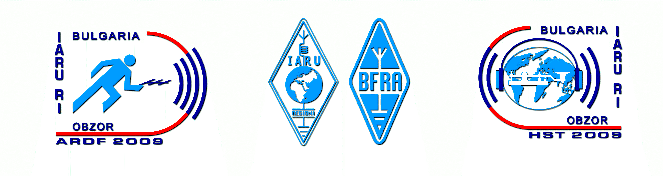

Bulletin No 1
(15 December 2008)

8th World High Speed Telegraphy Championship
11-15 September 2009
Obzor, Bulgaria

Bulgarian Federation of Radio Amateurs (BFRA) is pleased to invite High Speed Telegraphy (HST) teams, individual competitors and visitors/guests from all over the world to 8th World HST Championship to be held in Bulgaria in September 2009.

Venue:
The Championship will be held in Obzor, situated at Black Sea coast, 60 km south of Varna and 60 km north of Burgas. Obzor is a relatively small town (population 2400), but one of well known Bulgarian sea resorts. Many factors make it a preferable destination for the summer vacation – ecologically pure region, 5-km-long beach, active nightlife.

Correspondence and information:
Address for correspondence: BFRA, P.O. Box 830, BG-1000 Sofia, Bulgaria
Telephones: +359 894 292211, +359 2 8090377
E-mail: bfra_hq@hotmail.com
Websites: www.bfra.org, www.hst2009.eu, www.ardf2009.eu

Transportation to the venue:
Some of the teams travel, as tradition, by their own bus/cars. The rest may select their final destination amongst Burgas International Airport, Varna International Airport or the relevant Railway Station in these towns. Sofia International Airport is located relatively away from the venue (440 km) but the organisers will provide transfers to the venue and back upon request.

Accommodation:
The accommodation will be organised in a luxury four-star hotel located only 50 m apart of the beach. Triple rooms with WC, bath, and TV are provided. Double and single occupancy accommodation is available upon request (see bellow). Accommodation prior and post Championship is also available upon request.

Weather:
The weather in this period of the year is stable, usually sunny, with daily temperatures (both air and water) 22–23 degrees C, in other words – ideal for vacation and swimming.

Visa requirement:
The citizens of majority countries expected to take part in the Championship do no need visa to enter Bulgaria. Those societies that need visa will be informed accordingly after receiving their Letter of Intent.

Program of the Championship:
11 September, Friday – Arrival, accommodation, official opening;
12 September, Saturday – Competition, awarding;
13 September, Sunday – Competition, awarding;
14 September, Monday – Day off, excursion, awarding, closing ceremony and banquet;
15 September, Tuesday – Departure.

Entry fee and terms of payment:
There are lots of options depending on the status of the participants, needs of accommodation/full board, and date of payment as follows:
Total package including accommodation (all inclusive), free day excursion, and closing banquet:
a) For competitors and Team officials: Euro 249 if paid till 30 June or Euro 269 if paid after 30 June;
b) For guests/visitors: Euro 179 if paid till 30 June or Euro 189 if paid after 30 June;
c) Double occupancy accommodation: the relevant prices above plus Euro 30 per person;
d) Single occupancy accommodation: the relevant prices above plus Euro 50 per person.

Transfers:
The price to Obzor and back per person is as follows:
From Burgas International Airport, Varna International Airport or relevant Railway Station: Euro 25;
From Sofia International Airport: Euro 60.

Additional opportunities:
Other high level amateur radio competitions will be held in the same hotel in Obzor – 17th IARU Region 1 Amateur Radio Direction Finding (ARDF) Championships (16 – 21 September 2009). This circumstance creates a great opportunity for those who want to combine both events and spend a splendid vacation at the seacoast. The price for the whole period 11 – 21 September is the one shown above plus:

Euro 190 if paid till 30 June or Euro 200 if paid after 30 June and includes accommodation (all inclusive), second excursion and second banquet (after ARDF Championships). For double or single occupancy accommodation –respectively plus Euro 30 or Euro 50 per person.

Important notes
1. Please find enclosed a LETTER OF INTENT. It must be fulfilled and sent back to reach the organisers at least on 10 March 2009.
2. All the additional information and next Bulletins will be distributed only to societies that have responded and only to the contact person regarding the Championship. The information will also be available on the website of the Championship www.hst2009.eu
3. Bulgarian Federation of Radio Amateurs would like to draw your attention on the fact that the Championship will be held during the vacation season when all the hotel reservations must be made in advance. Therefore BFRA will consider all late entries (received after 10 March 2006) with a willingness to help but without any guarantee that they will be satisfied and participants accepted.

Bulgarian Federation of Radio Amateurs

8th World HST Championship
11-15 September 2009, Obzor, Bulgaria

LETTER OF INTENT

We:

(Full name of the society) (Official abbreviation)

intend to take part in the 8th World Championship in Obzor, Bulgaria, 11 – 15 September 2009 and would like to apply for participation. Our delegation will consist of:

1. Number of competitors:

2. Number of officials (if not competitors):

3. Number of guests/visitors:

TOTAL NUMBER of participants in this event (1+2+3):

4. Number of participants, included in the above number, which will also attend the 17th IARU Region 1 ARDF Championships (see Bulletin No 1):

Note: The referees for the International Jury are not included in the above number and will be personally invited.

Contact person regarding the Championships (responsible for the correspondence with BFRA)

Name and Family Name, Callsign:

Telephone number (including country and area codes):

Fax number (including country and area codes):

E-mail:

On behalf of the society:

(Name and Family name, Position in the society, Signature)

Date:

Please fulfill and send back this Letter of Intent (to reach BFRA on 10 March 2009 at latest) to:

BULGARIAN FEDERATION OF RADIO AMATEURS
P.O.BOX 830
BG-1000 SOFIA, BULGARIA

or (preferably) by e-mail to: bfra_hq@hotmail.com

We are looking forward to meeting you in September in sunny Obzor at the Black Sea coast!

Bulgarian Federation of Radio Amateurs

