International Amateur Radio Union Region 1
Bulgarian Federation of Radio Amateurs

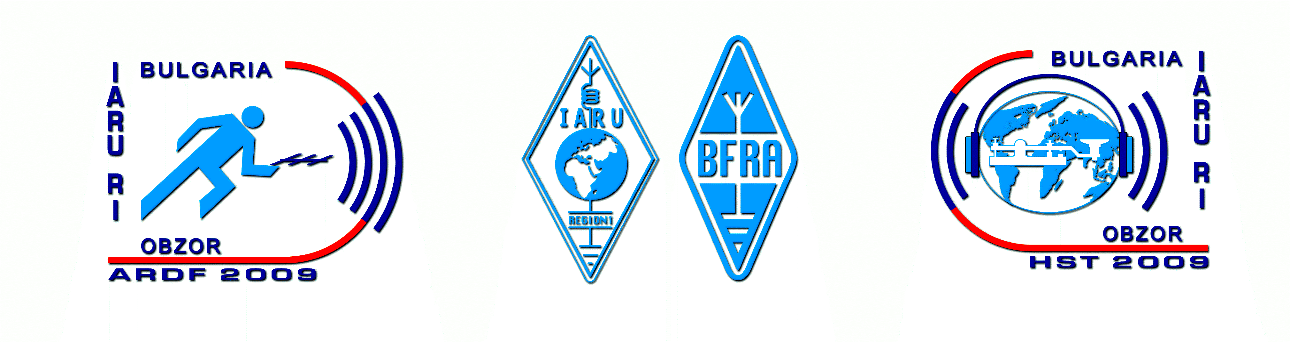

Bulletin No 1
(15 December 2008)

17th IARU Region 1 Amateur Radio Direction Finding Championships
16-21 September 2009
Obzor, Bulgaria

Bulgarian Federation of Radio Amateurs (BFRA) is pleased to invite ARDF teams, individual competitors and visitors from IARU Region 1 as well as guests from all over the world to 17th IARU Region 1 ARDF Championships to be held in Bulgaria in September 2009.

BFRA is proud to host that event in a jubilee year marking 50 years ARDF activity in Bulgaria (1959 – 2009)

Venue:
The Championships will be held in Obzor, situated at Black Sea coast, 60 km south of Varna and 60 km north of Burgas. Obzor is a relatively small town (population 2400), but one of well known Bulgarian sea resorts. Many factors make it a preferable destination for the summer vacation – ecologically pure region, 5-km-long beach, active nightlife.

Correspondence and information:
Address for correspondence: BFRA, P.O. Box 830, BG-1000 Sofia, Bulgaria
Telephones: +359 894 292211, +359 2 8090377
E-mail: bfra_hq@hotmail.com
Websites: www.bfra.org, www.ardf2009.eu, www.hst2009.eu

Transportation to the venue:
Some of the teams travel, as tradition, by their own bus/cars. The rest may select their final destination amongst Burgas International Airport, Varna International Airport or the relevant Railway Station in these towns. Sofia International Airport is located relatively away from the venue (440 km) but the organisers will provide transfers to the venue and back upon request.

Accommodation:
The accommodation will be organised in a luxury four-star hotel located only 50 m apart of the beach. Triple rooms with WC, bath, and TV are provided. Double and single occupancy accommodation is available upon request (see bellow). Accommodation prior and post Championships is also available upon request.

Weather:
The weather in this period of the year is stable, usually sunny, with daily temperatures (both air and water) 22–23 degrees C, in other words – ideal for vacation and swimming.

Terrains:
The terrains are located within 50-km range. They are mid-difficult, with small hills, covered with forest. The maps (IOF standard) will be reambulated in early 2009.

Visa requirement:
The citizens of majority countries expected to take part in the Championships do no need visa to enter Bulgaria. Those societies that need visa will be informed accordingly after receiving their Letter of Intent.

Program of the Championships:
16 September, Wednesday – Arrival, accommodation;
17 September, Thursday – Training on both bands, official opening;
18 September, Friday – First competition, awarding;
19 September, Saturday – Day off, excursion;
20 September, Sunday – Second competition, awarding, closing ceremony and banquet;
21 September, Monday – Departure.

Entry fee and terms of payment:
There are lots of options depending on the status of the participants, needs of accommodation/full board, and date of payment as follows:
a) Total package for competitors and Team officials: Euro 279 if paid till 30 June or Euro 299 if paid after 30 June, includes accommodation (all inclusive), free day excursion, transportation to the start and from the finish, maps, and banquet;
b) Total package for guests/visitors (out of participants and Team officials): Euro 210 if paid till 30 June or Euro 220 if paid after 30 June, includes accommodation (all inclusive), free day excursion, transportation to the start and from the finish, and banquet;
c) Double occupancy accommodation: the relevant prices above plus Euro 30 per person;
d) Single occupancy accommodation: the relevant prices above plus Euro 50 per person.

Transfers:
The price to Obzor and back per person is as follows:
From Burgas International Airport, Varna International Airport or relevant Railway Station: Euro 25;
From Sofia International Airport: Euro 60.

Additional opportunities:
1. A training camp will organized during the week prior the Championships with daily trainings on both bands. Details will be published in Bulletin 2.
2. Another high level amateur radio competition will be held in the same hotel in Obzor – 8th World High Speed Telegraphy Championship (11 – 15 September 2009). This circumstance creates a great opportunity for those who want to combine both events and spend a splendid vacation at the seacoast. The price for the whole period 11 – 21 September is the one shown above plus:

Euro 190 if paid till 30 June or Euro 200 if paid after 30 June and includes accommodation (all inclusive), second excursion and second banquet (after HST Championship). For double or single occupancy accommodation –respectively plus Euro 30 or Euro 50 per person.

Important notes
1. Please find enclosed a LETTER OF INTENT. It must be fulfilled and sent back to reach the organisers at least on 10 March 2009.
2. All the additional information and next Bulletins will be distributed only to societies that have responded and only to the contact person regarding the Championships. The information will also be available on the website of the Championships www.ardf2009.eu
3. Bulgarian Federation of Radio Amateurs would like to draw your attention on the fact that the Championships will be held during the vacation season when all the hotel reservations must be made in advance. Therefore BFRA will consider all late entries (received after 10 March 2006) with a willingness to help but without any guarantee that they will be satisfied and participants accepted.

Bulgarian Federation of Radio Amateurs

17th IARU Region 1 ARDF Championships
16-21 September 2009, Obzor, Bulgaria

LETTER OF INTENT

We:

(Full name of the society) (Official abbreviation)

intend to take part in the 17th IARU Region 1 ARDF Championships in Obzor, Bulgaria, 16 – 21 September 2009 and would like to apply for participation. Our delegation will consist of:

1. Number of competitors:

2. Number of officials (if not competitors):

3. Number of guests/visitors:

TOTAL NUMBER of participants in this event (1+2+3):

4. Number of participants, included in the above number, which will also attend the 8th World HST Championship (see Bulletin No 1):

Note: The referees for the International Jury are not included in the above number and will be personally invited.

Contact person regarding the Championships (responsible for the correspondence with BFRA)

Name and Family Name, Callsign:

Telephone number (including country and area codes):

Fax number (including country and area codes):

E-mail:

On behalf of the society:

(Name and Family name, Position in the society, Signature)

Date:

Please fulfill and send back this Letter of Intent (to reach BFRA on 10 March 2009 at latest) to:

BULGARIAN FEDERATION OF RADIO AMATEURS
P.O.BOX 830
BG-1000 SOFIA, BULGARIA

or (preferably) by e-mail to: bfra_hq@hotmail.com

We are looking forward to meeting you in September in sunny Obzor at the Black Sea coast!

Bulgarian Federation of Radio Amateurs

