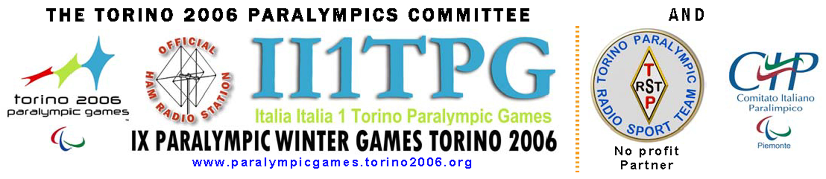
Introduces
“TORINO 2006 PARALYMPIC GAMES ARS AWARD”

It is a technical sport meeting, all the SWL and amateur radio in the world are participating.
The goal of the meeting is to create a larger awareness and interest towards Paralympic Games, both Winter and Summer, - IX Paralympic Winter Games Torino 2006 10-19 March 2006, and particularly to offer an ulterior opportunity to make known the sporting activities performed by disabled person s, and of course the possibilities of these people to integrate not only socially, but physics, therapeutics, and recreational, enhancing the benefits received performing sports, not only competitive sports.
The techniques and equipment tried by radio or the listening process made by the disabled find practical application and are put at the disposal of the community to get over the handicaps.
The “Torino 2006 Paralympic Games ARS Award” starts on 1° January 2000, permanent award

and the sponsorship of: REGIONE PIEMONTE, CO.RE.COM – Comitato Regionale Comunicazioni Piemonte, PROVINCIA DI TORINO, Comune di Torino.
with the cooperation of: Informa disAbile www.comune.torino.it/pass, CDD Centro Diurno Disabili Giaveno TO,
AIR Associazione Italiana Radioascolto www.arpnet.it/air

RULES

The QSO/HRD for this award are valid only from 1st January 2000.
PARTECIPANT s: Ann OM and SWL worldwide.
BAND: HF 10,15,20,40, 80 meter and Warc - VHF (6 and 2 meters); with regard to band plan and current laws.
MODI: CW, SSB, digital (RTTY, SSTV,PSK31, etc.), FM (only 10 meters).
Contacts made on relay station or cable (EchoLink, e-QSO, etc.) are not valid.

Procedure to be entitled to the award

Award one must be connected to Amateur Radio Stations in the Countries of the Paralympic Games

AWARD  category | ARS | Total qso | QSO with ARS in the Regione Piemonte | And n. DXCC Entities  (out of 16) | DXCC ENTITIES
HF | Italy | 16 | 1 | 15 | AUSTRALIA (VK), AUSTRIA (OE), CANADA (VE), FRANCE (F), GERMANY (DL), ENGLAND (G), JAPAN (JA), GREECE (SV), ISRAEL (4X), ITALY (I), SOUTH KOREA (HL), NORWAY (LA), NETHERLANDS (PA), SPAIN (EA), UNITED STATES (W), SWEDEN (SM)
HF | Europe
HF | Rest of the World
6 m | Italy | 10 | 1 | 9
6 m | Europe
6 m | Rest of the World
VHF 2 m | Italy | 5 | -- | 5
VHF 2 m | Europe
VHF 2 m | Rest of the World

wild cards: The connection made with the special call II1TPG
or ARS “i1 - ik1 - iw1 - iz1“ replaces one missing country, for not more than three different countries.

The Call II1TPG active: 2004 - 2005 for pre e test event and 01.01 - 31.03.2006

To obtain Award please send:
- Summary of Log complete in every part (remember that the SWL must indicate 2 names for every listening, the receiving station plus the working of same);
- Statement of two licensed radio amateurs must certify it.
- Diploma cost for both categories refundable expense of forwarding is: 3 IRC's or 5 Euro or US$ 5.
- The request is closed envelope, enclosing forwarding expenses with sender clearly indicated to:
IZ1CCE Carlo SOBRITO, PARALYMPIC AWARD - Via I° Maggio 9 – 10051 AVIGLIANA (TO) ITALY.
Other information: award@ii1tpg.it o iz1cce.to@tin.it- info: www.ii1tpg.it

