« Republic of Kazakhstan 15th Anniversary »

Issued by UN1II (Sergey N. Borissov) and Radio Amateurs of Aktobe.

Terms and conditions:
The Diploma is dedicated to the 15th anniversary of the Republic of Kazakhstan on October 25, 2005 and is presented for radio contacts with the radio amateur stations of Kazakhstan during the period of time from 22th to 25th of October, 2005.

5 points are issued for each radio contact on 22nd, 23rd and 24th of October.
10 points are issued for each radio contact on 25th of October.
Special Station UO15I
10 points are issued for each radio contact with UO15I on 22nd, 23rd and 24th of October.
15 points are issued for each radio contact with UO15I on 25th of October.
In total, no less than 15 points needed in order to receive the Diploma.

Recurring contacts are counted if the contact has been carried on different bands and different modulations.
The Diploma is issued to SWL for the same terms and conditions.
The cost of the Diploma is 2 USD (4 IRC)– for radio amateurs from CIS countries, 3 USD (6 IRC) – for radio amateurs from foreign countries.
Shipping and handling cost is included.
Applications should be presented as an extract from log and sent to the manager of the Diploma: 030000, Kazakhstan, Aktobe, PO Box 113, to Sergey N. Borissov
Applications are also accepted via e-mail: un1ii@qrz.ru
Certification of an application is not required.
Diploma is available in Russian and English Language.
The period of applying is limited!
The deadline is 31st of December 2005
If anyone wants to get the Diploma fast – we can send it by DHL or FedEx. In this case all the details should be discussed by e-mail.

Author:
E-mail: un1ii@qrz.ru, Sergey N. Borissov, UN1II, ex. UN7IKK

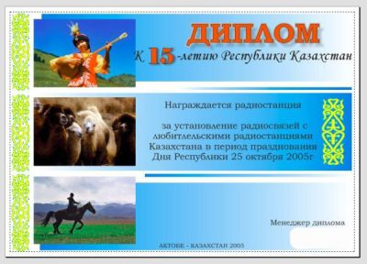
On This Picture – Diploma on Russian Language.

