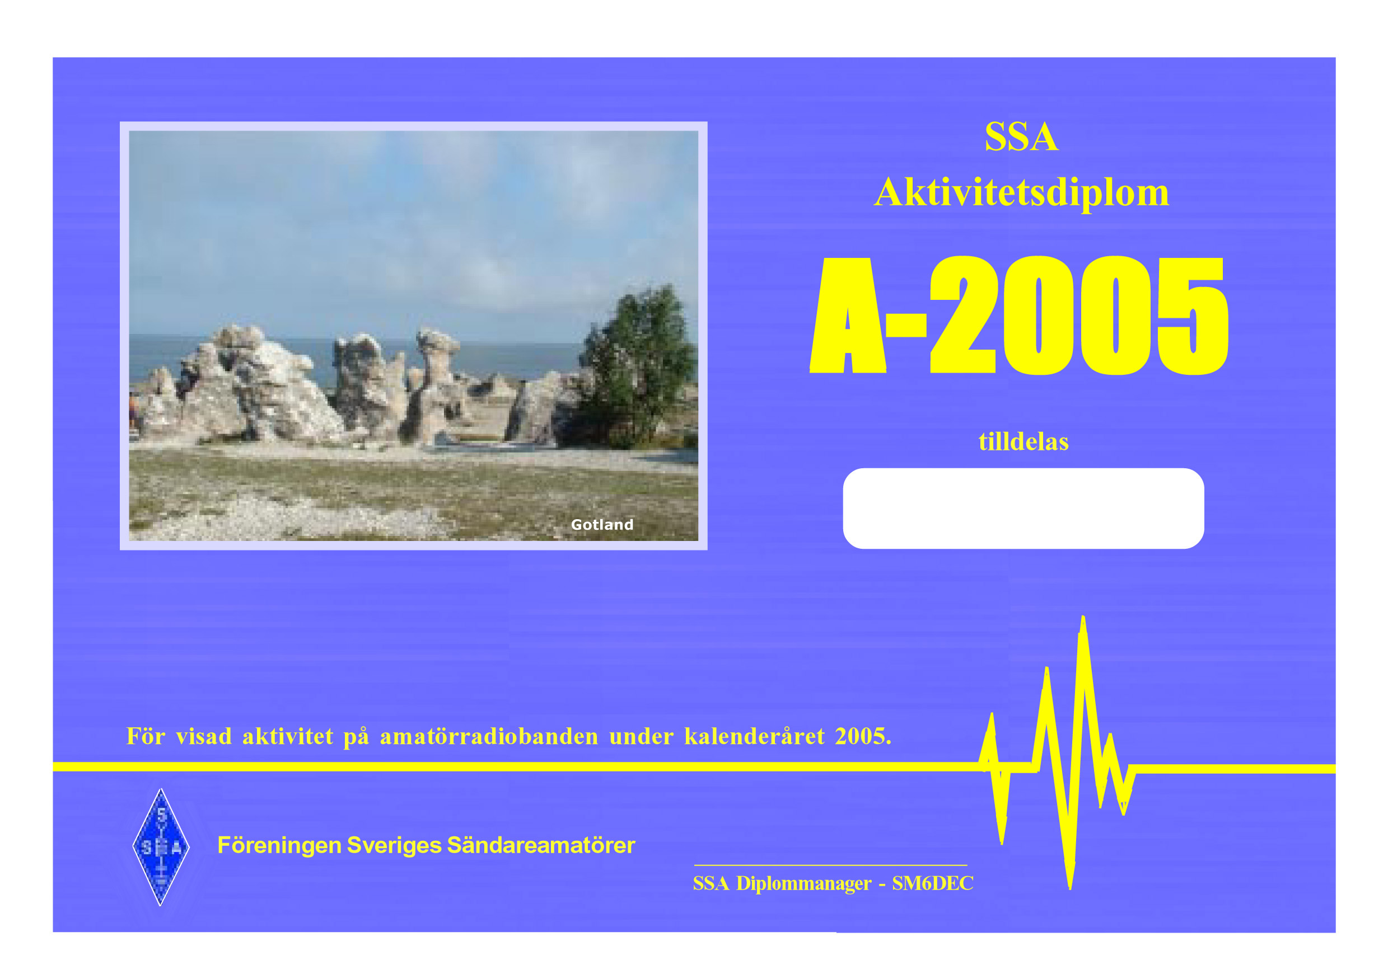

size 21x15 cm

SSA Activity Award 2005 – A-2005

This award is open to radio amateurs and SWL to promote operating activity on our amateur radio bands.
Work (or hear) 365 radio contacts during 2005-01-01 -- 2005-12-31.
All bands and all modes are allowed.
The same station may be worked several times.
The award fee is 5 USD or 5 Euro. Apply with a simple statement, like:
" I have made at least 365 radio contacts during 2005."
Apply to SSA Awards Manager, Bengt Hogkvist, SM6DEC, Ostbygatan 24 C, SE-53137 Lidkoping Sweden.

Next year (etc) similar rules for A-2006 (etc).
Each year a new photo on the certificate from another Swedish County (laen).

